**PROJECT REPORT**

**IE 580 – SYSTEMS SIMULATION**

**PRODUCTIVITY IMPROVEMENT THROUGH LINE BALANCING IN A TEXTILE MANUFACTURING INDUSTRY USING ARENA**

**Submitted to**

# Prof. Seokcheon Lee

Department of Industrial Engineering

Purdue University

**Team Number 3**

**Members**

Akilan Anbukani

Arvind Ajaykumar

Satwik Krishnan

Rajiv Rai

**21 April, 2017**

**TABLE OF CONTENTS**

**TITLE PAGE NUMBER**

Summary 3

Introduction 4

Problem Description 8

Potential Solution Approaches 8

Simulation Modeling 10

Design of Experiments 12

Analysis 13

Conclusion 15

References16

**ACKNOWLEDGEMENT**

We would like to place on record our sincere thanks to Mr. Mariappan, Chairman of Penguin Apparels (P) Ltd, India for giving us this opportunity to do this project.

We also humbly thank Penguin Apparels Unit 4 production supervisor, Mr. Muthupandi, for spending his valuable time performing time study and providing us with the data that we needed.

We are deeply indebted to our professor, Dr. Seokcheon Lee, Department of Industrial Engineering, Purdue University for his kind guidance and monitoring of the project that we undertook.

**SUMMARY**

The goal of the project was to develop a more efficient production system of the product “Ergobaby 360 Performance Carrier” at Penguin Apparels (P) Ltd headquartered in Madurai, India. Such an improvement can help the industry to improve their productivity and gain a competitive advantage in the market.

Project Objectives were:   
1) Identify the potential areas for line balancing

2) Reduce the inventory waiting and operator idle time

3) Increase the overall profits of the industry as a whole

4) Using simulation to explore alternatives

Company Overview:

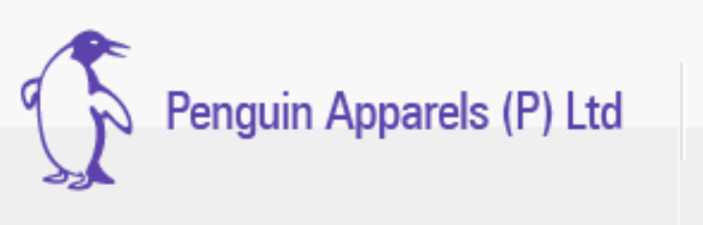



Penguin Apparels (P) Ltd is a small-scale apparel manufacturing industry in Madurai, Tamil Nadu. The company was started in the year 1990 and manufactures shirts for Ralph Lauren, US polo, denim jackets for degree 7 and baby carriers for Ergobaby. They are a leading garment manufacturer in south India with 18 units. The project is carried at Unit 4.

**INTRODUCTION**

In the current age, there are a lot of challenges for industries that utilize the assembly line to obtain their products. The first is the need to assemble many product models and their variants in their lines, due to the variety required by the market. Another challenge is the need to maintain an adequate level of manpower occupation and other utilized resources. In this scenario, the activity of balancing operations appears. To increase the efficiency and reduce the operating costs of the line, various balancing activities among workstations are performed. They can be done by different methods, such as: exact, heuristics, meta-heuristics methods, or simulation.

Hence, the aim of our project is to design a simulation using ARENA for Penguin Apparel Pvt. Ltd. for leveling the workload across all processes in a cell or value stream and hence removing bottlenecks and excess capacity. The product under consideration for our project is Ergobaby 360 Performance Carrier, which is manufactured at Unit 4, Penguin Apparels Pvt. Ltd. The product design is shown below:

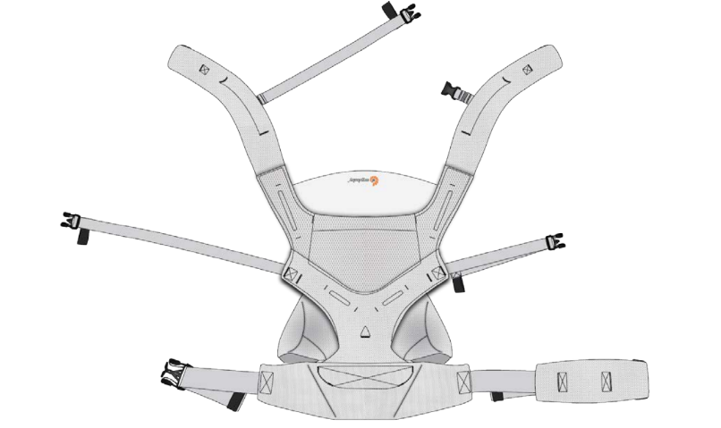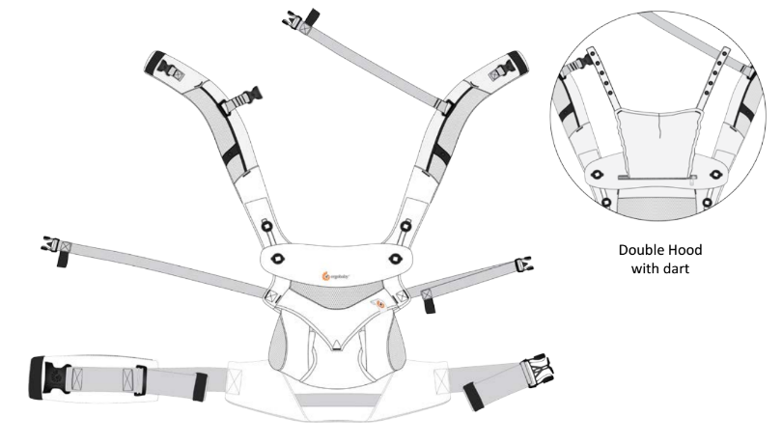

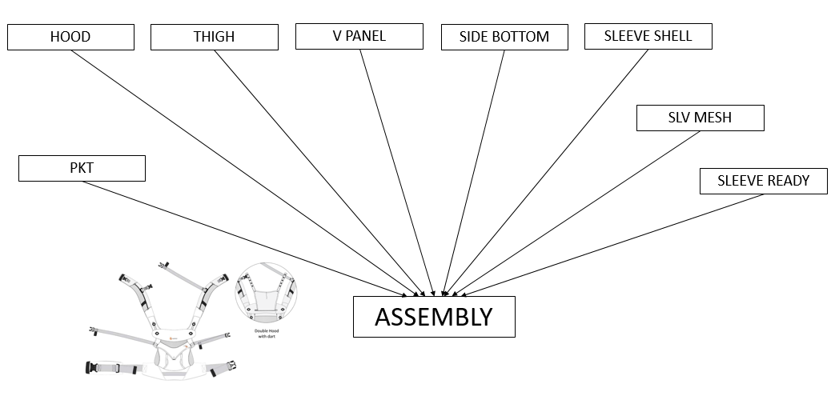

The above diagram shows the basic structure in the manufacturing of the final product. The sub-components Hood, thigh, V-panel, side bottom, sleeve shell, sleeve mesh, sleeve ready and pocket are made simultaneously and assembled together finally.

The data containing the list and sequence of processes involved in the production of the product along with the processing times for each operation (with 10 replications each) was obtained from the company. The final, cleaned data for two of the processes is shown in the table below. The final data for the rest of the processes can be found in the attached Excel document.



**Development of Facility Layout with Process Flow Integration**



Using the process flow data obtained from the company, the above shown facility layout was developed to aid the building of the simulation model in Arena.

**Project Structure**

**DATA COLLECTION**

Process flow

Processing time of each operator

Calculate

Facility layout

Takt time

Develop simulation model based on current data

Run the model and analyze the results:

**Non-Value Added activities**

Waiting time for each part

Queue length at each operator

Recalculate

Develop better models after line balancing

Simulate better models

Arrive at best model

Improve productivity

**PROBLEM DESCRIPTION**

With the introduction of the ‘Make in India’ initiative, small scale companies are emerging and the competition in the market has become cut-throat. Hence, it has become important to do more with less. Our project focuses on line balancing and efficiency improvement in the production flow at Penguin Apparels Pvt. Ltd., Madurai, India. We plan to level the workload across all processes in a cell or value stream to remove bottlenecks and excess capacity.

## Reasons for simulation

1. The production process involves many processes and sub-processes. Identification of zones for improvement is made easy by using simulation techniques.
2. The model would be helpful in testing combination of decisions for increasing utilization & profit and suggest most influential set of decisions.
3. Number of resources and entities involved is large – manual calculation will be very tedious.
4. No cost is involved in simulation, i.e. no financial risk.

**POTENTIAL SOLUTION APPROACHES**

The potential solution approaches can be defined through the following 3 models:

1. The first modelling was done by analyzing the collected regular data from the industry and running it with ARENA. The overall process involved 9 different sub-products manufactured separately, which are eventually assembled to create the final product.
2. After running the first model, the data was analyzed. The takt time from the customer side was given as 0.86 minutes per product. Therefore, to bring down the lead time, all the sub-products which had an average waiting time in the queue of more than 1 minute, another operator was added for that specific product. This reduced the overall waiting time for the final assembly and increase the productivity. This is known as the Greedy Approach, since we are optimizing only at the local level and not at the global level.
3. In the third model, we aimed at optimizing the process globally to increase production. After analyzing the data, there were queues which had (number of parts x processing time) lesser than the takt time. Due to this, there was a delay in the assembly of the final product. To eliminate it, we added extra resources (operators) to these queues in order to quicken the process and match the takt time of all the other parts and the final product.

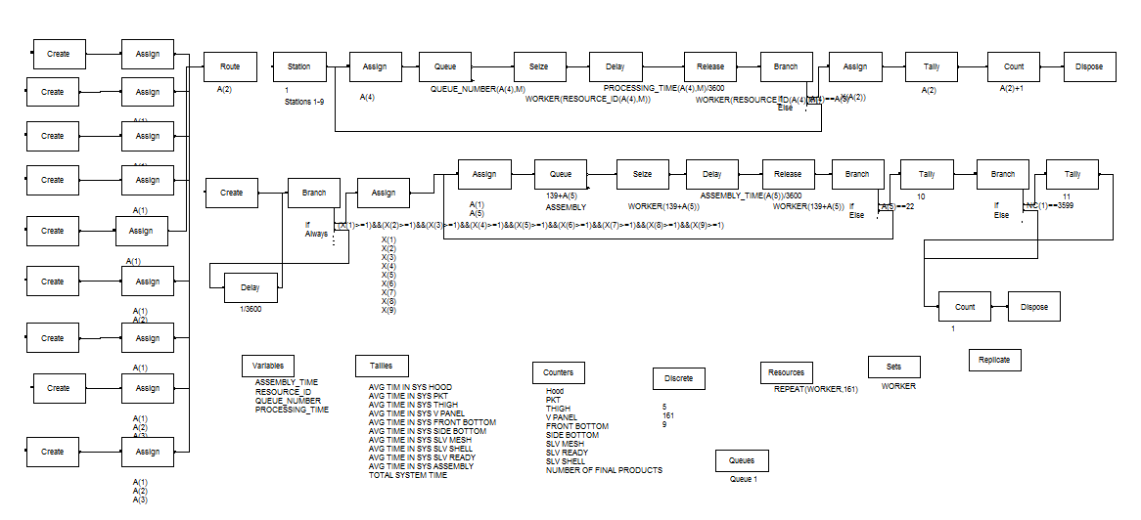**SIMULATION MODELING**

Fig. Basic Model

The above figure demonstrates the ARENA model for the first solution approach. Here, data was collected and fed in the system in the crude form. This helped us to analyze the current system of production in the industry and recommend improvements that have been used in designing the Optimized Models 1 and 2.

****Fig. Optimized Model 1

In this model, the results of the simulation of the basic model were analyzed. The overall waiting times in select queues were reduced through the “Greedy approach”, where additional operators were added to queues having longer average waiting time.

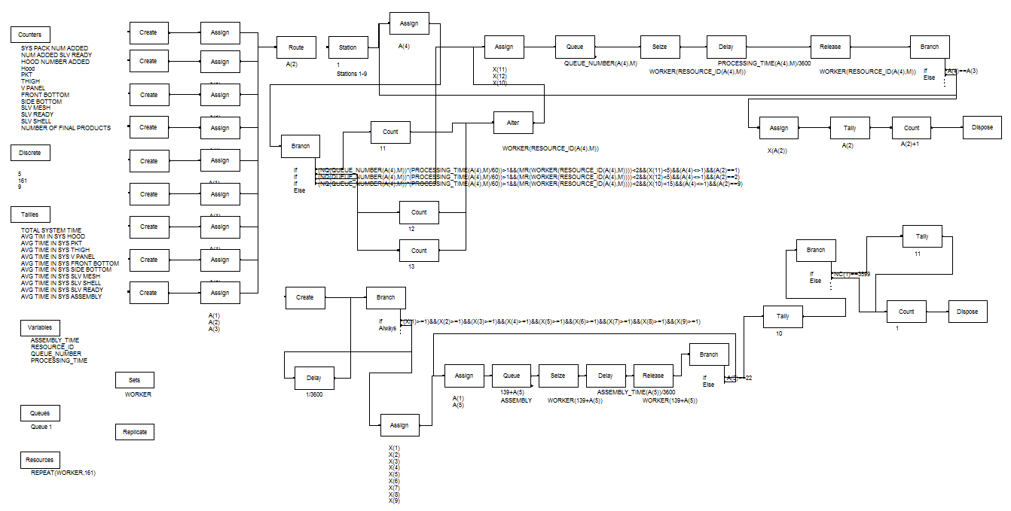

Fig. Optimized Model 2

From the results of the simulation in Optimized Model 1, we observed that the production of the sub-products Hood, Pocket and Sleeve Ready were the bottle necks that eventually decreased the throughput of the Assembly. So, in the Optimized Model 2, we added extra resources – at those points in the three sub-processes – using Alter block to at those times during the simulation when the (number of parts x processing time) metric became lesser than the takt time.



**DESIGN OF EXPERIMENTS**

**ANALYSIS**

As seen in the ‘if’ conditions shown above, a maximum of 5 extra operators are permissible to be added to Hood and Pocket and 10 to Sleeve ready. The condition also ensures that the maximum number of operators at a processing unit does not exceed 2.

**DESIGN OF EXPERIMENTS**

From the overall collected data, the results of time studies were extracted through design of experiments. The mean and standard deviation were calculated from the number of repeated time values. Time study was carried out by the supervisor and ten repetitions of time were taken at different times of the day. For example, for the first process of attaching the label, following was the time study data:

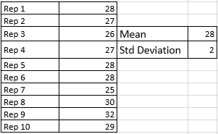

Similarly, time calculations were done for every process and was documented.

The transportation time for the entire process was calculated. Eventually, after carrying out ANOVA with the 2 factors viz. transportation and process time, it was found that the p-value was greater than α at 95% confidence interval. Hence, the transportation time was insignificant in comparison to the process times. This was because it is a flow shop industry with all the machines and operators located close to each other, and hence there is no major movement involved.

**ANALYSIS**

Following is the process analyzer output for the process:

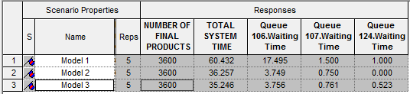

Of the three models, ‘Optimized 2’ (Model 3) is the best model. The graph below shows the performance of the three models.

|  |  |  |  |  |
| --- | --- | --- | --- | --- |
| **Model number** | **Model name** | **Products produced per day** | **Products produced per month** | **Number of operators** |
| 1 | Base | 476 | 11438 | 167 |
| 2 | Optimized 1 | 794 | 19062 | 190 |
| 3 | Optimized 2 | 818 | 19636 | 183 |

Model 1 produces 476 carriers per day. The number of working days in a month is 24 including national holidays and Sundays as holidays. Model 1 has the minimum most operators. Model 2 is a good example where greedy approach does not necessarily produce the best results. It results in addition of more operators but does that increase the productivity more that model 3. Model 3 gives the best results by adding only 16 more operators compared to 23 by model 2.

Improvement is preferred only when it is cost-effective. Hence a cost analysis is performed to compare the three models.

|  |  |  |  |  |  |  |  |
| --- | --- | --- | --- | --- | --- | --- | --- |
| **Model No.** | **Number of operators** | **Increase in operators** | **Increase in products** | **Increase in operator costs** | **Increase in machine costs** | **Increase in income** | **Increase in profit per year** |
| 1 | 167 | - | - | - | - | - | - |
| 2 | 190 | 23 | 7624.300164 | 2208000 | 121900 | 2424527.452 | 94627.45214 |
| 3 | 183 | 16 | 8198.336167 | 1536000 | 84800 | 2607070.901 | 986270.901 |

Model 1 is the current design in the production plant and hence it is kept as the base model. Model 2 and 3 improvements are compared with that of model 1. An increase in operator includes increase in machines as tailors need the sewing machine to carry out the operations. The cost of adding an operator is 8000 INR per month (salary of the tailor per month) plus cost of a Juki sewing and stitching machine is 5300 INR per year as the cost of a machine is 53000 INR and the life is 10 years. The profit from selling one Ergobaby carrier for Penguin Apparels (P) Ltd is 318 INR. Thus, the increase in profit per year compared to 1 is calculated for models 2 and three.

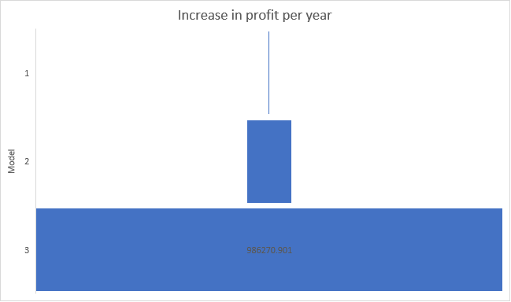

From the above figure, it is inferred that model 3 is the best model as it gives the highest profit of 986270.9 INR per year.

**CONCLUSION**

Thus, of the three models that were developed, it is found that Model 3 is the best model. Through the successful implementation of line balancing using the techniques suggested, Penguin Apparels Unit 4 can increase their production of Ergobaby 360 performance carrier from 476 to 818 per day thereby, gaining an additional profit of **986,270.9 INR** every year.

**REFERENCES**

1. Aqil, M. (2016). Design, Simulate and Analyze Cafeteria System using Arena. *International Journal of Mechanical and Industrial Technology*.
2. Kelton, W. (Second Edition). *Simulation with Arena.* McGraw Hill.
3. Khalid, R. (2013). A Discrete Event Simulation Model for Evaluating the Performances of an M/G/C/C Queuing System. *PLOS*.
4. Abdul Talib Bon, Nur Nasihah Shahrin (2016), Assembly Line Optimization using Arena Simulation, *International Conference on Industrial Engineering and Operations Management* Kuala Lumpur, Malaysia, March 8-10, 2016
5. “Efficiency Improvement of a Plant Layout” – Vol.3, issue 4, April 2014 by Vivekanand.S et al., published in International Journal of Innovative Research in Science,Engineering and Technology. ISSN: 2319-8753.
6. “A Survey on Lean manufacturing implementation in Malaysian Automotive Industry” – Vol.1, No.4, October 2010. ISSN: 2010-0248.
7. “An Application of Production Excellence through Value Flow” –vol.1 and issue 6 June 2014 by Ravindra Ojha, Sanjay Katyal, Sanjay Sethi published in Industrial Engineering Journal. ISSN: 0970-2555.